**ML-Assignment 1**

Linear Regression

Analysis of the datasets using Linear Regression. We have four datasets namely data1, data2, data3 and data4 . Analysis had been done for each of these data sets individually. In analysis we mainly focused on mean square error, mean absolute error, root mean square error and root square for the respective datasets. First we calculate these error by custom code and then we compared it with the scikit learn library.

Data Set 1

|  |  |  |  |  |  |  |
| --- | --- | --- | --- | --- | --- | --- |
| **Output by** | **MAE** | **MSE** | **RMSE** | **R-Square** | **Cost by GD** | **Cost by Numerical** |
| **Numerical** | 1.280556 | 2.078525 | 1.4417091949 | 0.9998767 | **[[5.68078713 2.38406007]]** | **[[5.68078713 2.38406007]]** |
| **scikitlearn** | 1.280556 | 2.07525 | 1.441709145 | 0.95796 |

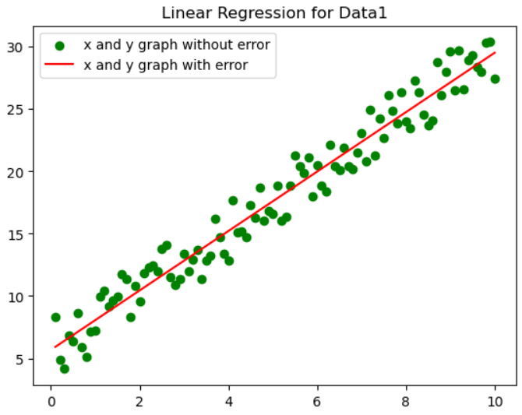

Analysis

Dataset 1: The dataset exhibits a notable linear trend when visualized on the x and y axes. The high R-squared value of 0.9579571905586357, nearing 1, suggests a robust linear relationship between the variables. Consequently, this dataset is well-suited for application with the standard Linear Regression algorithm.

**Dataset 2 :**

|  |  |  |  |  |  |  |
| --- | --- | --- | --- | --- | --- | --- |
| **Output by** | **MAE** | **MSE** | **RMSE** | **R-Square** | **Cost by GD** | **Cost by Numerical** |
| **Numerical** | 99929.7832 | 27577785853.1640 | 166065.607074927 | 0.46225 | **[[-125568.289921341603.63156151]]** | **[[-125568.28992133 41603.63156151]]** |
| **scikitlearn** | 99929.783297 | 27577785853.1634 | 166065.607074927 | 0.34339 |

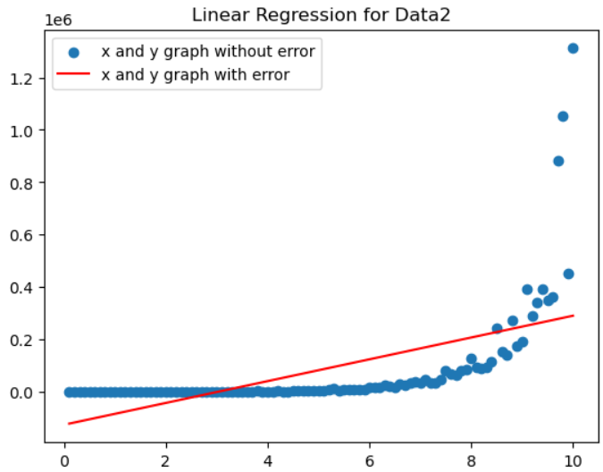

Analysis

Dataset2: At the outset, the dataset suggested an exponential trend among its data points. However, following a logarithmic transformation applied to the input features, the transformed data assumed a linear appearance. The R-squared value of 0.34339 Consequently, to render this dataset suitable for the standard Linear Regression algorithm, a nonlinear transformation of the input features is essential. The first plot illustrates the relationship between x and y before the transformation. If we convert this exponential into linear than this will best fit the line , this is because in that case our R-squared value turn out to be 0.9993234 which is closely to 1.

Dataset3:

|  |  |  |  |  |  |  |
| --- | --- | --- | --- | --- | --- | --- |
| **Output by** | **MAE** | **MSE** | **RMSE** | **R-Square** | **Cost by GD** | **Cost by Numerical** |
| **Numerical** | 0.161730 | 0.294678 |  | 0.999999856 | **[[1.17706208 0.09419021]]** | **[[1.17706208 0.09419021]]** |
| **scikitlearn** | 0.161730 | 0.294678 |  | 0.31370 |

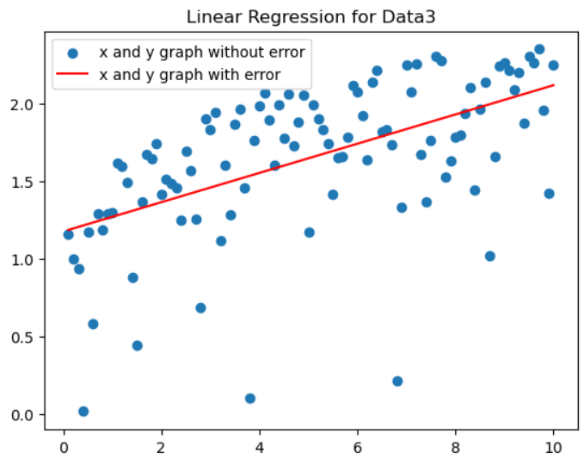

Analysis

Dataset3: The widespread dispersion of points in the plane necessitates a nonlinear transformation of input features to establish an improved best-fit curve. In this dataset, the data points were widely scattered on the graph, posing challenges in identifying a clear pattern or relationship. With an R-squared value of 0.31369732267280803, considerably distant from 1, the evidence points to a weak linear connection between the variables. Consequently, the conventional Linear Regression algorithm may prove inadequate for this dataset. Exploring alternative regression methods or algorithms capable of handling non-linear relationships could be more suitable.

Dataset 4:

|  |  |  |  |  |  |  |
| --- | --- | --- | --- | --- | --- | --- |
| **Output by** | **MAE** | **MSE** | **RMSE** | **R-Square** | **Cost by GD** | **Cost by Numerical** |
| **Numerical** | 5.155506 | 34.620481 | 5.883917133 | 0.99829 | **[[13.23947579 6.13243433 2.3922683 7.74681094]]** | **[13.23947782 6.13243763 2.39226554 7.74681038]]** |
| **scikitlearn** | 5.155506 | 34.6420481 | 5.883917113 | 0.98417 |

Analysis:

Dataset4:

Consistent 𝑅-squared values near 1 from both sklearn and my analysis suggest a good fit for multivariate regression. The high 𝑅² indicates our model captures a large part of the data's variation. Lower MAE means our predicted curve closely follows the best-fit curve on average. Additionally, with an RMSE of 5.88 and an impressive R-Squared of 0.9983, our model exhibits strong performance, displaying minimal average errors and explaining nearly all the dataset's variability. In summary, our multivariate regression model demonstrates accuracy and effectiveness in representing the underlying patterns in the data.